  
This product is only written **online**, not on paper.

**Here is the ONLINE APP process:**

1)       Go to <https://eapp.gtlic.com/AgentPortal/Menu>

2)      Enter your login account

3)      Click QUOTE &SUBMIT



**4)      Complete the following information, then click NEXT.**

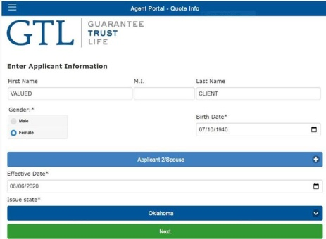

**5)        SELECT THE PRODUCT:  GTL HERITAGE PLAN WHOLE LIFE; THEN CLICK GTL HERITAGE PLAN WHOLE LIFE COVERAGE**

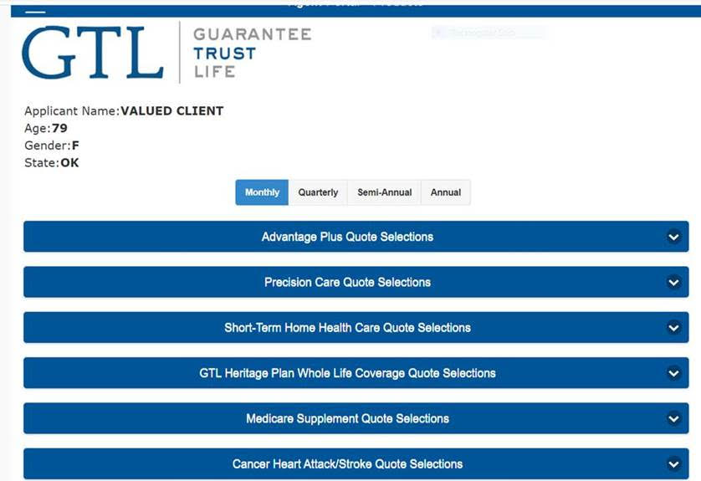

**6)** **COMPLETE THE FOLLOWING INFORMATION, THEN A QUOTE WILL GENERATE.  IF THE QUOTE IS OKAY, AND THE CLIENT IS READY TO APPLY, CLICK APPLY NOW:**

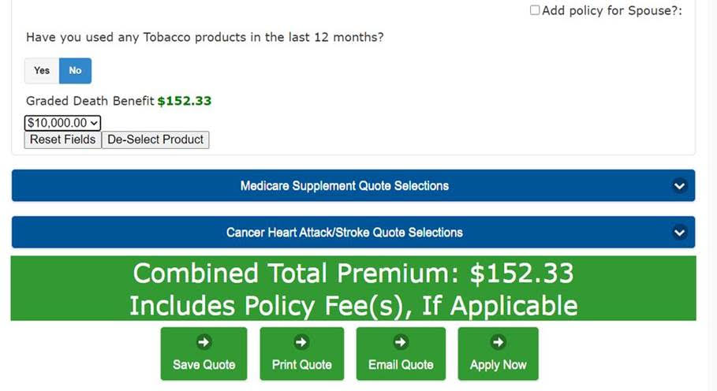

**7)       FOLLOW THEN THE SUCCEEDING INSTRUCTIONS BY COMPLETING THE APPLICATION FORMS.  THE QUESTIONS ARE THE SAME AS THE SAMPLE APPLICATION FORM.**

**8)      COMPLETE THE PHONE VERICATION CALL.  PLEASE SEE ATTACHED INFORMATION.**

